Microbiome Section Report Questions

1. Pictures above, I chose the numbers because of when the quality score began to drop.
2. qiime dada2 denoise-paired \

--i-demultiplexed-seqs demux.qza \

--p-trim-left-f 0 \

--p-trunc-len-f 240 \

--p-trim-left-r 0 \

--p-trunc-len-r 210 \

--o-representative-sequences rep-seqs-dada2.qza \

--o-table table-dada2.qza \

--o-denoising-stats stats-dada2.qza

1. In order to skip the mv command I could just change the name of the files in the code above. I would say “ --o-table table.qza \” for example. And I would simply change the command to

“qiime metadata tabulate \

--m-input-file stats.qza \

--o-visualization stats.qzv”

1. All you have to do it change the file name in the command to whatever you have instead of the name the tutorial has.

1. My top hits

1. The code is filtering the table.qza file to exclude mutochondia and chloroplast. It is important to do this step because
2. There are no changes in the “top hits” because the command did not actually filter out anything. The taxonomy file did not change at all so I got the same “hits”.

I already filtered and re-ran the codes

Will probably have to delete the core-metrics-results folder and do the alpha diversity commands again ☹

1. My top two phyla are Alphaproteobacteria and Epsilonproteobacteria

My top 5 classes are campylobacterales, Burkholderiales, Rhizobiales, Actinomycetales, Pseudomonadales

1. Alpha diversity is a measure in diversity. The number of different species in a community. While Beta diversity is the difference between these communities. It compares the different communities and we see how diverse they are compared to eachother.
2. My sampling depth that I chose was 1098 because I visualized the table.qzv file which gave me the number when I looked in the Interactive Sample Detail. After choosing this number, I lost 3 samples and kept every other sample.
3. The graphs were generated for Sex, Flock, and Population using the metadata file. They are not significant because the q-values are over 0.05. However the flocks q-value is 0.06 which is still over but it means this is the most significant of the 3 although it is still not significant. Shannon diversity measures the size of each bacteria (species) in each observed feature (population). (**PICS AT BOTTOM OF DOCUMENT)**
4. The beta diversity for sex was not significant because the q-value was over 0.05. It was also not significant for flock because the q-value was 0.19 which is over 0.05 as well. And finally the population beta diversity was also not significant because the q-values was 0.09 which is still over 0.05. This means that the different communities are pretty similar. (**PICS AT BOTTOM OF DOCUMENT)**
5. There is no grouping between the communities based on their bacterial enviorment. (**PICS AT BOTTOM OF DOCUMENT)**

Alpha Diversity

Beta Diversity

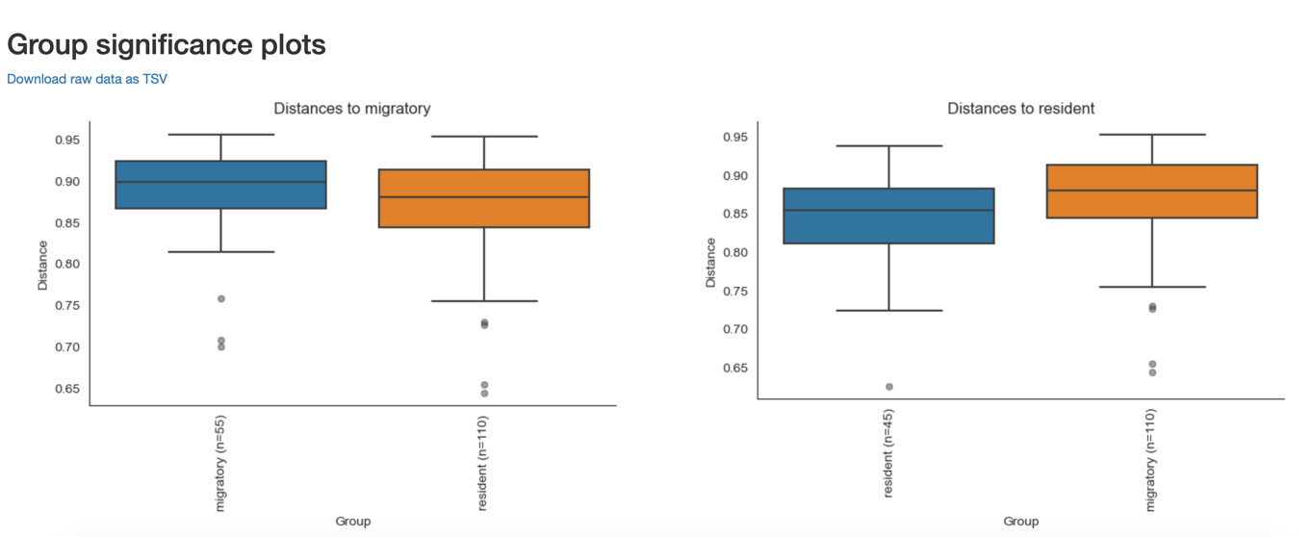

Bray_Curtis_Emperor.qzv

